**API End Points and Communication**

**Day 17: 1 April 2025 28**

1st project : Eureka Server

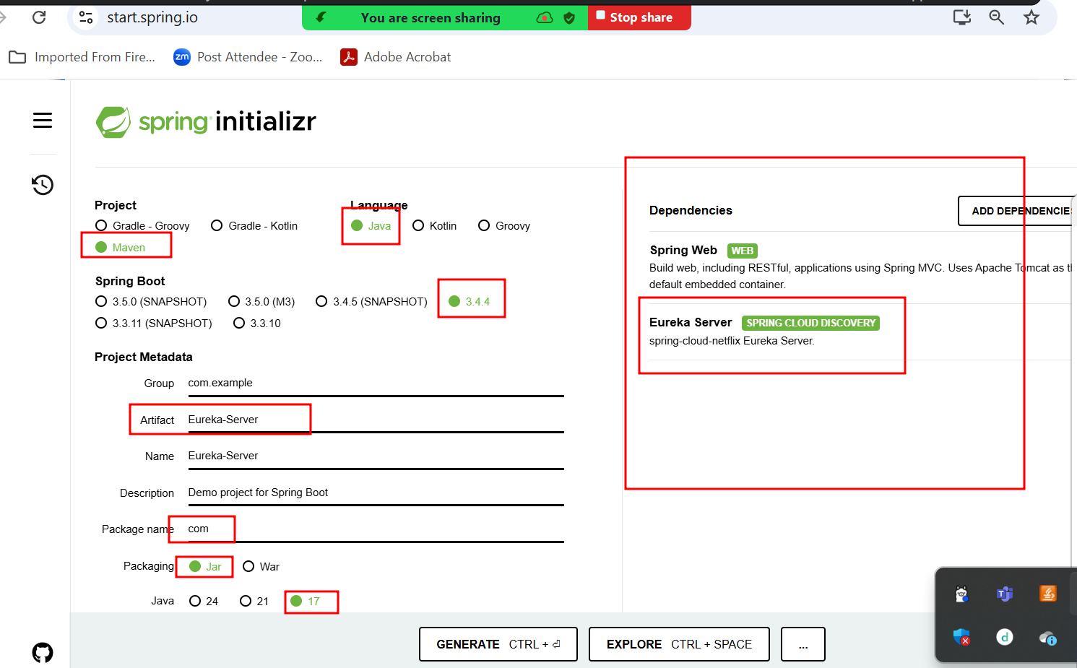

First micro service project **book_micro_service_app**

Port Number : 8181

**Starter 🡪web Starter**

**Starter 🡪 jpa starter**

**Dependency 🡪 mysql connector**

**Starter -🡪 thymeleaf for view**

**Starter -🡪 devtool for refresh the project**

**Starter 🡪 eureka discovery client**

**Index.html**

**CName -🡪 Steven**

**Source -🡪**

**Destination -🡪**

**Book the Cab**

**Table or entity class**

**Bid, Cname, source, destination, amount**

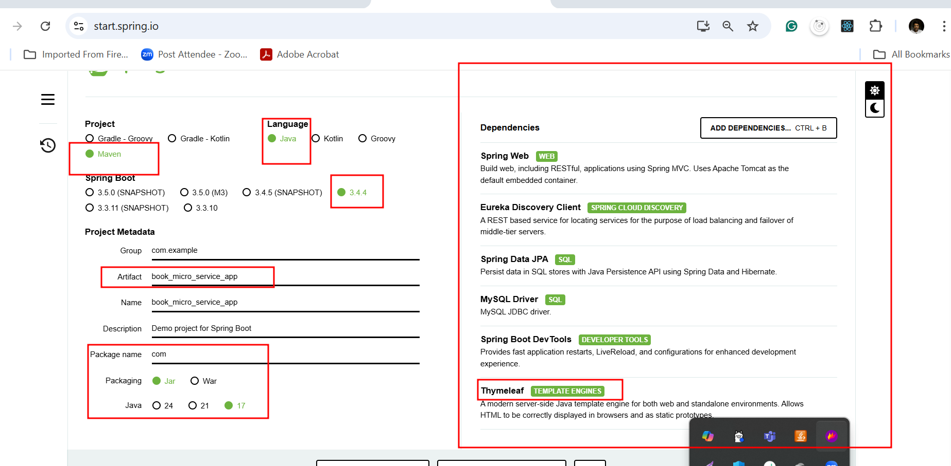

Second micro service project **cab_fare_micro_service_app**

Port Number : 8282

**Starter 🡪web Starter**

**Starter 🡪 jpa starter**

**Dependency 🡪 my connector or h2 database (in memory database)**

**Starter -🡪 devtool for refresh the project (please don’t add this starter)**

**Starter 🡪 eureka discovery client**

**Create rest api with post method to store car fare details.**

PK with auto increment

Srno source destination fare

1 A B 100

2 B C 80

3 C A 120

**Post method**

<http://localhost:8282/fare/store>

{“source”:”A”,”destnation”:”B”,”amount”:100}

Need to create rest api which takes source and destination details and base upon these details provide the fare or amount.

**Get method**

<http://localhost:8282/fare/findFare/A/B> 100

<http://localhost:8282/fare/findFare/C/A> 120

<http://localhost:8282/fare/findFare/D/A> -1

return amount 100 else return -1

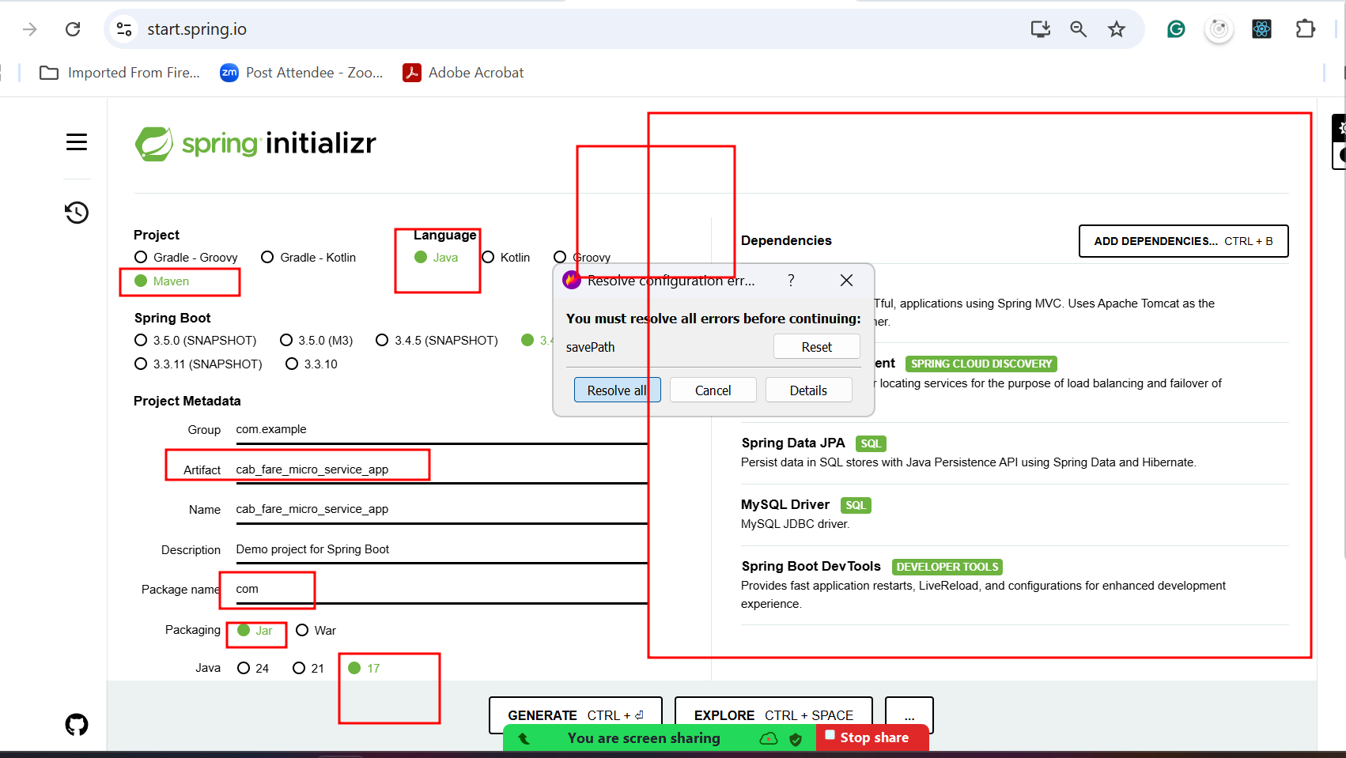

SQL Query

Select fare from CabFare where source = “” and destination = “”;